Example: CRUD Operations using Persistence service using GUID
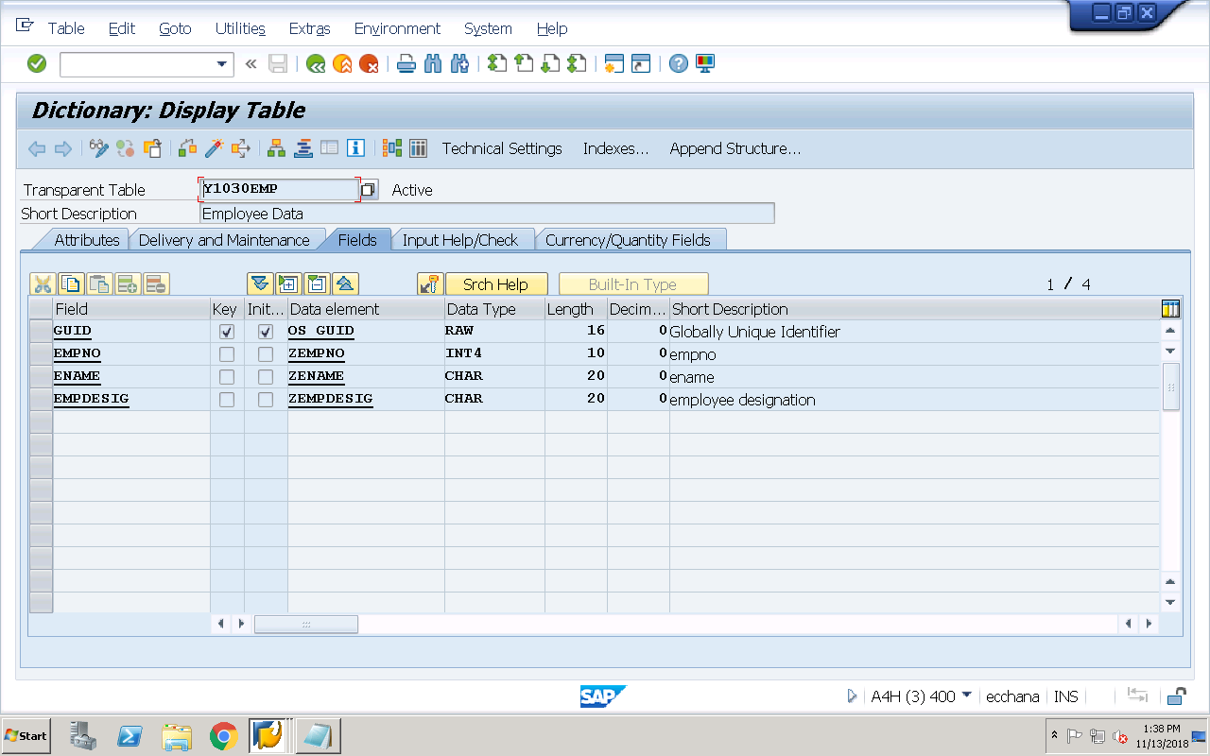
REPORT Z1030OOPS43.
data : o_actor type ref to yca_1030emp,
o_pers type ref to ycl_1030emp,
k type ref to object.
PARAMETERS : p_guid type y1030emp-guid,
p_empno type y1030emp-empno,
p_ename type y1030emp-ename,
p_desig type y1030emp-empdesig.
SELECTION-SCREEN begin of block bk1 with FRAME title t1.
PARAMETERS : p_r1 RADIOBUTTON GROUP grp1 USER-COMMAND fc1,
p_r2 RADIOBUTTON GROUP grp1,
p_r3 RADIOBUTTON GROUP grp1,
p_r4 RADIOBUTTON GROUP grp1,
p_r5 RADIOBUTTON GROUP grp1 DEFAULT 'X'.
SELECTION-SCREEN end of block bk1.
INITIALIZATION.
o_actor = yca_1030emp=>agent.
at SELECTION-SCREEN on RADIOBUTTON GROUP grp1.
case sy-ucomm.
when 'FC1'.
if p_r1 = 'X'.
perform createpersistentobject.
elseif p_r2 = 'X'.
perform deletepersistentobject.
elseif p_r3 = 'X'.
perform modifypersistentobject.
elseif p_r4 = 'X'.
perform readpersistentobject.
endif.
endcase.
FORM createpersistentobject .
TRY.
CALL METHOD o_actor->create_persistent
RECEIVING
result = o_pers.
if o_pers is bound.
* set the values for non-key fields
o_pers->set_empno( p_empno ).
o_pers->set_ename( p_ename ).
o_pers->set_empdesig( p_desig ).
commit work.
endif.
CATCH cx_os_object_existing .
message 'Object Existing exception while creation' type 'I'.
ENDTRY.
ENDFORM.
FORM readpersistentobject .
TRY.
CALL METHOD o_actor->if_os_ca_persistency~get_persistent_by_oid
EXPORTING
i_oid = p_guid
receiving
result = k.
if k is bound.
free o_pers.
* o_pers = k. "syntax error
o_pers ?= k. "widening cast
if o_pers is bound.
* read the non-key field values
clear : p_empno,
p_ename,
p_desig.
p_empno = o_pers->get_empno( ).
p_ename = o_pers->get_ename( ).
p_desig = o_pers->get_empdesig( ).
endif.
endif.
CATCH cx_os_object_not_found .
message 'Object not found exception while reading' type 'I'.
CATCH cx_os_class_not_found .
message 'Class not found exception while reading' type 'I'.
ENDTRY.
ENDFORM.
FORM deletepersistentobject .
* check the existence of persistent object
TRY.
CALL METHOD o_actor->if_os_ca_persistency~get_persistent_by_oid
EXPORTING
i_oid = p_guid
receiving
result = k.
if k is bound.
free o_pers.
* o_pers = k. "syntax error
o_pers ?= k. "widening cast
if o_pers is bound.
* delete the persistent object
TRY.
CALL METHOD o_actor->if_os_factory~delete_persistent
EXPORTING
i_object = o_pers.
commit work.
CATCH cx_os_object_not_existing .
message 'Object not existing for deletion' type 'I'.
ENDTRY.
endif.
endif.
CATCH cx_os_object_not_found .
message 'Object not found exception while reading' type 'I'.
CATCH cx_os_class_not_found .
message 'Class not found exception while reading' type 'I'.
ENDTRY.
ENDFORM.
FORM modifypersistentobject .
* check the existence of persistent object
TRY.
CALL METHOD o_actor->if_os_ca_persistency~get_persistent_by_oid
EXPORTING
i_oid = p_guid
receiving
result = k.
if k is bound.
free o_pers.
* o_pers = k. "syntax error
o_pers ?= k. "widening cast
if o_pers is bound.
* modify the non-key fields
o_pers->set_empno( p_empno ).
o_pers->set_ename( p_ename ).
o_pers->set_empdesig( p_desig ).
commit work.
endif.
endif.
CATCH cx_os_object_not_found .
message 'Object not found exception while reading' type 'I'.
CATCH cx_os_class_not_found .
message 'Class not found exception while reading' type 'I'.
ENDTRY.
ENDFORM.

